Exercise 4 deep learning lab 2018

Max Fuchs
Matriculation number: 4340529
maxfuchs@gmx.de

1. Introduction
The task in exercise 4 was to use Baysian optimization(BO) and Hyperband(HB) to optimize the hyperparameters of an surrogate benchmark. In a final step, BO and HB were combined. The resulting optimizer Bohb was as well tested on the surrogate.

2. Implementation
As already mentioned in the introduction, a surrogate benchmark was used to test the different optimization algorithms. This surrogate enables to test hyperparameter configurations in a very short time, by using a regression model of the hyperparameter space . The reg. Model is based on a prior training with a large set of different hyperparameter settings. In the following the hyperparameters of a CNN, namely the learning rate, batch size and the filter sizes for tree layers, are optimized.

3. Optimizers

3.1 Baysian optimization

The basic idea of baysian optimization is to keep track of past evalution results, and use them to predict the next hyperparameter settings. Therefore BO chooses the next setting in an informed manner, in contrast to grid- or random search [1].
XXX more detailed information
The results of an optimization for 20 iterations can be seen in figure 1. It can be seen that a local validation error minimum can be found already after 5 iterations. Interestingly the found minimum, is seldomly further decreased with increasing runtime.
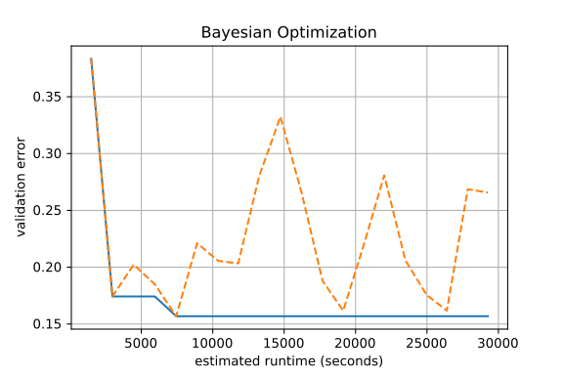figure 1:

3.1. Hyperband
This optimization algorithm underlys the principle, that if an parameter combination performs best in long terms, it is likely that it will perform in the top half of a random set of configurations after a small number of iterations. To achieve this, a set of random parameter configurations of size n is drawn, with r beeint the initial number of iterations. The algorithm executes successive halving in several combinations of n and r, to trade off breadth versus depth[2]. These combinations can be seen in figure 2, with s denoting the different combinations, and representing the tradeoff. The blue dots, represent set that are trained. These get trained for r epochs. After that only the best performing half of the set keeps on training for epochs(orange dots). This is done until the stopping criterion is met, in each training step with half the amount of sets and double the epoch budget from the last iteration. The last configurations s = 0, is therefor trained on a very small amount of parameter sets with the maximum budget on epochs.
The best validation error for each run of s can be seen in table 1. Configuration s = 1, outperforms the other configurations. This shows that a tradeoff between breadth and depth is necessary.

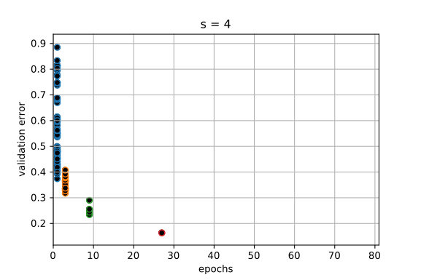 | 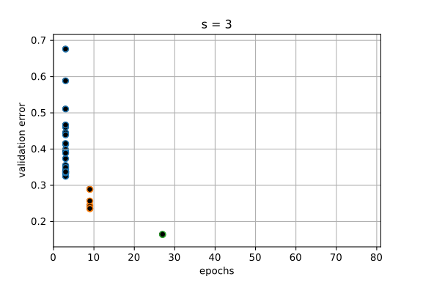
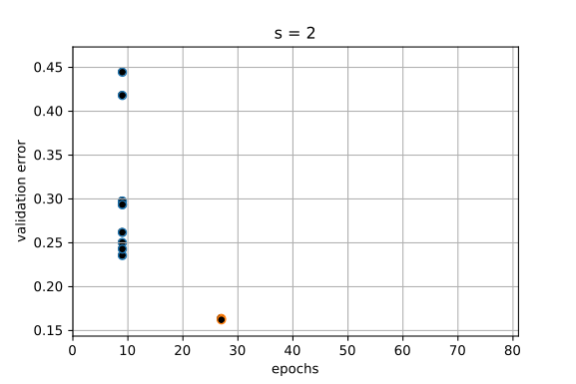 | 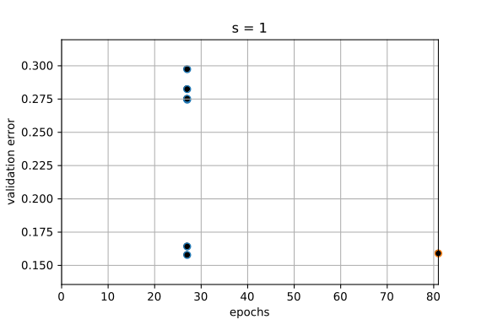
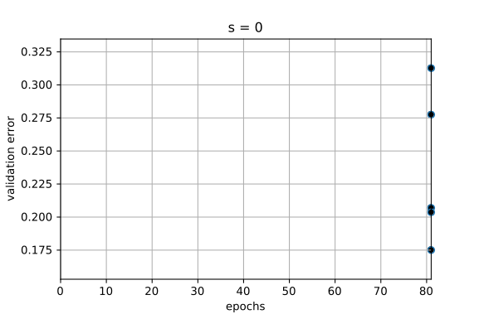
figure 2

s | 0 | 1 | 2 | 3 | 4
Val. error | 0.175 | 0.158 | 0.162 | 0.163 | 0.163
table 1:

3.2 Combination Baysian optimization and Hyperband (Bohb)
This approach trys to reduce the effect that Hyperband might take exponentially log to approach the global optimum, due to its random start configurations. To achiev this, only a fraction of the hyperband input configurations is drawn randomly. The other fraction is generatet using Baysian optimization. figure 3 shows the performance, for random and model based hyperparameter configuration sets. It can be seen that in the first time of the training, only random configurations are drawn. This is intended and is necessary to provide enough start data for the baysian optimization. After about 150000 seconds, the first model drawn configurations are feed to Hyperband and evalutated. For that a set of random samples is sampled from a multivariate Normal. These configurations are evaluated by the acquisition function. Finally the expected improvement of the acquisition fucntoin is minimized and the related configuration is used for hyperband. It can also be seen that the model configurations are very close together. The amount these values are spread, represents the trade of between exploration in uncertain model areas and exploitation in the good regions of the configuration space.

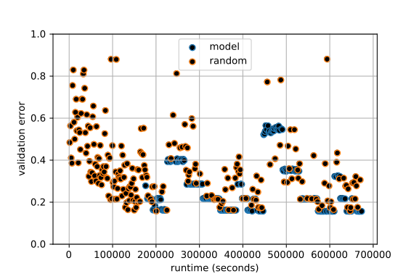figure 3:

4. Conclusion
Baysian optimization and Hyperband offer alternatives for hyperparameter optimization towards random - and grid search. Both methods follow different approaches and bring their own dis- and advantages. Therefor the approach of Bohb, tryes to combine the best of the two algorithms.

5. References

[1] | A Conceptual Explanation of Bayesian Hyperparameter Optimization for Machine Learning, Will Koehrsen, access: 30.12.2018, 12:18
[2] | Hyperband: A Novel Bandit-Based Approach to Hyperparameter Optimization,Lisha Li, Kevin Jamieson, Giulia DeSalvo, Afshin Rostamizadeh, Ameet Talwalkar,18 Jun 2018

